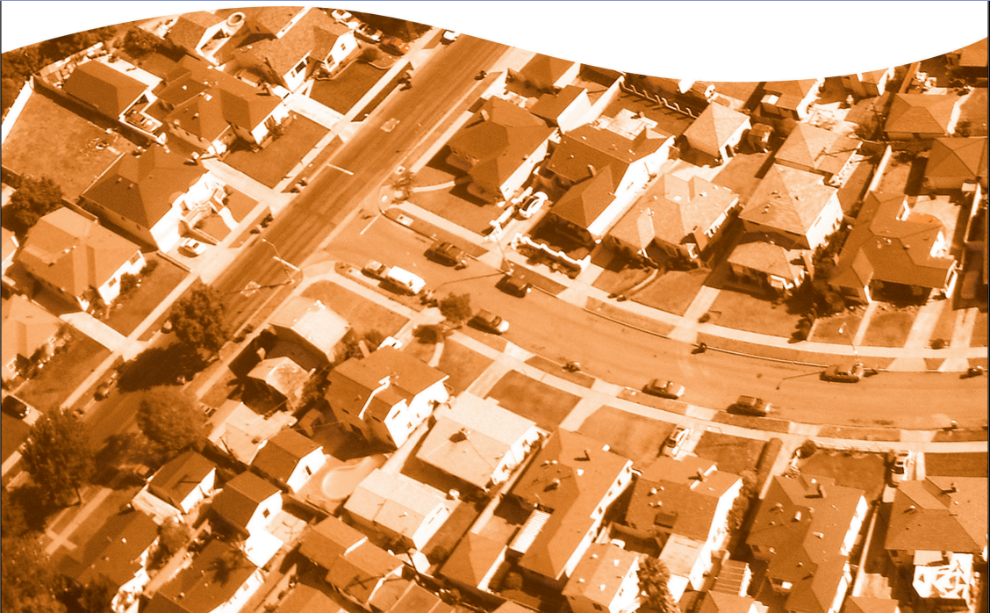

ITV Capture™

INSPECTION REPORT

Insured’s Copy

**InspekTech®**  
#401, 800-15355-24th Ave,  
Surrey, British Columbia V4A 2H9

www.InspekTech.com





**WE RECOMMEND AGAINST SENDING THIS REPORT   
TO YOUR CLIENT.**

*This ITV Capture™ report is intended for Insurance Underwriters, Agents, Brokers and other trained insurance Professionals. We recommend against providing this full unabridged report to your clients as untrained readers may misinterpret industry   
concepts, leading to possible push-back.*

*We supply every ITV Capture™ report with a* ***Client Copy*** *whose data is unchanged, though the format and some inclusions are abridged. Also, included are commonly raised issues plainly addressed to avoid potential push-back if read and understood by the insured.*

**If your client asks for a copy, provide them the   
Client Copy**by logging into the file. Then, simply   
download it instantly.

**ITV Capture™**



replacement value inspection report

www.InspekTech.com

**Sam Sam, Jam Jam**

**401, 15355, 401, 15355 Best Ave , 24 Ave Surrey, BC V4A 2H912  
Replacement Cost: $Value Insert**



SUMMARY REPORT

Date of Site Visit: **n/a**

Policy No: 987654321

Customer No: 123445

InspekTech ID: 4712929   
Insured: Sam Sam, Jam Jam  
Site Contact: Sam William

____________________________________________________

COMPANY/BROKER

Company: 0394810 B.C. LTD.

Requester: EVANS, PHIL (P)

**IMPORTANT NOTE TO READER: InspekTech®** does not purport to list all hazards and will not be responsible to the Customer for any loss or damage, consequential or otherwise, however caused, incurred or suffered, as a result of the services being provided. This observation report is based on information obtained at the time of the survey, code information when and where available, and principles and practices that can or may be considered as industry standard. The ITV value provided will be developed utilizing the power of **CoreLogic® Residential Component Technology (RCT)** and any other CoreLogic tools to provide a building replacement value for the subject dwelling based on a non-measured inventory of exterior and interior components and features. The estimated size of the dwelling has been taken from property taxation or similar records and has not been verified. The value provided is an estimate only, as based on standardized regional data for the dwelling type.

REPLACEMENT COST SUMMARY

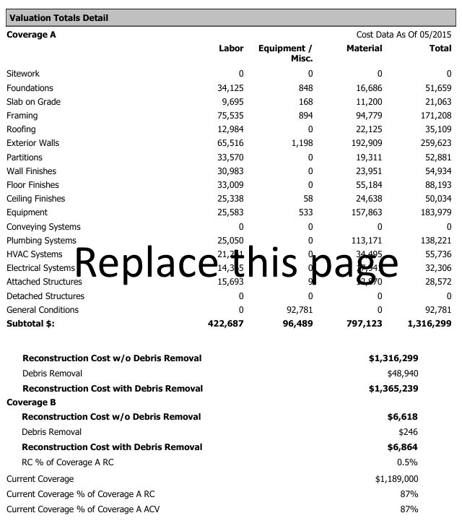

|  |  |  |  |  |  |
| --- | --- | --- | --- | --- | --- |
| Building Data | | | | | Building Photos |
| Year Built: 2018 | | | Building Style: 1 Story; 1.5 Story; 2 Story; 2.5 Story | |  |
| Type of Construction: | | | Standard | |
| Foundation Types: | | | Crawl Space, Excavated, 100% | |
| Foundation Materials: | | | Concrete | |
| Foundation Conditions: | | | Good | |
| (i) Total Building Area * | | | n/a | |
| (ii) Finished Living Area (FLA) * | | | n/a | |
| (iii) Total Living Area (TLA) * | | | n/a | |
| Exterior Condition Summary | | | | |
| Exterior Wall Conditions: | | | n/a | |
| Roof Surface Conditions: | | | n/a | |
| Approximate Roof Age: | | n/a | n/a years | |
| Exterior Features | | |  | |
| 0 |  | | 2 | Door, Raised Panel, Birch |
| Array |  | | 30% | Aluminum Sash with Glass |
| Array |  | | 0 |  |
| 30% | Aluminum Sash with Glass | | 2 sqft | Door, French, sq.ft |
| General Exterior Comments: This is a test exterior comment | | | | |
| Interior Condition Summary | | | | |
| Condition of Walls/Floors/Ceilings | | | Good Maint. w/high value finishes | |
| Interior Features | | | **Kitchen(s)** | |
| Central Burglar Alarm System | | | Semi-Custom 1 | |
| Entertainment System, Audio/Video | | |
| Wet Bar | | | **Bathroom(s)** | |
| Stairs, Straight, Open One-Sided, Hardwood | | | ; 1/2 Bath, Custom 3; 3/4 Bath, Designer 1 | |
| Stairs, Curved, Granite | | |
| Refrigerator, Sub-Zero | | |
| General Interior Comments: This is a test interior comment | | | | |
| Liability Observations | | | | |
| Handrails: | | | Missing in one or more places | |
| Guardrails: | | | Missing in one or more places | |
| Surface Conditions: | | | Average conditions, no concerns | |
| Pools & Hot tubs: | | | Pool area fenced + hot tub w/cover; Hot tub on deck, w/cover; Hot tub in deck w/cover; Hot tub in deck, no cover; Hot tub on deck, no cover | |
| Pets: | | | Large dog, appears friendly | |
| Exposures / Other Items: | | | This is a test exposure comment | |

*

***(i)******Total Building Area*** *is the total sq.ft within the building.* ***(ii) Finished Living Area (FLA)*** *is the sq. ft. measurement of the main living area but does not include the basement area (even if finished), any garage type, or lower level unfinished areas in the Finished Living Area (FLA). Any finished features in basement areas (including special rooms, kitchens, bathrooms, etc.) are valued and included in the home's inventory. Standard and custom finishing in basement areas are accounted for and integrated in the development of the replacement value of this report****. (iii) Total Living Area (TLA)*** *is the FLA plus any Built-in Garage space. This measurement reporting method is standard to the insurance industry. Sq. Ft measurements in this report may be approximate to within reasonable range for underwriting purposes.*

BUILDING

BUILDING MATERIALS SUMMARY

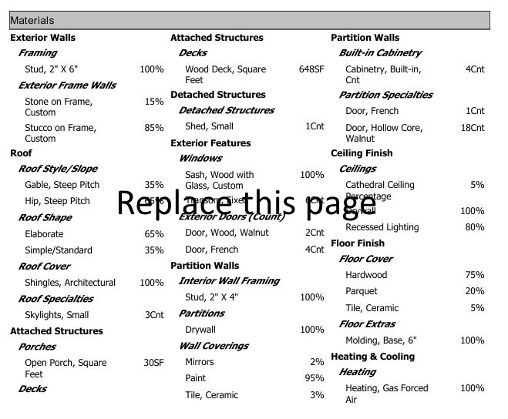

BUILDING MATERIALS SUMMARY *(Continued)*

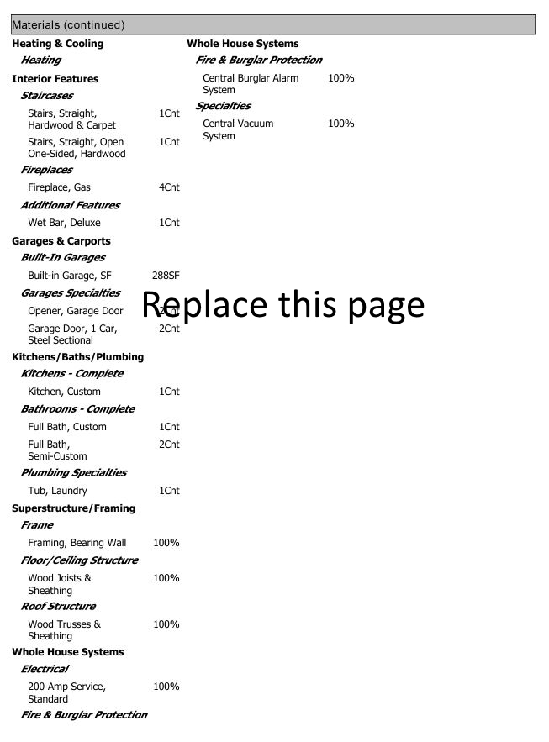

GENERAL SERVICES & SECURITY/ LIFE SAFETY/PROTECTION

|  |  |  |
| --- | --- | --- |
| Common Services for Dwelling | | Detached Structures & Features |
| electircal Service Type | Overhead | This is a test detahed comment |
| Electrical Service Panel(s) | Unable to locate or blocked from viewing |
| Clearance Concerns | Minor tree/ shrub blockage - Must have photo(s)!! |
| Elec. Service Rating | 200 Amp Service, Custom | Common Services & utitlity comments |
| Wiring Type | Mixed: Copper/Conduit | This is a test utility comment |
| Elec. Services Condition | Average, no problems observed |
| Heating Type | Heating, Gas Forced Air (Furnace) |
| A/C /Heat Pump: | Whole House Fan |
| HVAC Equipment Condition | New furnace and/or boiler system |
| Solid Fuel Appliances | Wood Stove | utitlity PHOTOS |
| Fireplaces | Fireplace, Gas (Chimney Flue) |  |
| Water Source | Private well |
| Water Supply Piping | Plastic pipe (PEX) |
| Waste Line Piping | Copper |
| Sewer service type | Septic Tank Field; Septic Tank + Sump Pump in basement |
| Plumbing Conditions | Average, no problems observed |
| Hot Water Tank | n/a |
| Hot Water Tank Age & Condition | yr, Good condition |
| Clothes Washer Hoses | Metal Flex, Good condition |
| Dryer Venting | Metal flex hose, Average condition |
| Security/protection services | |
| Security Alarm System | Monitored Alarm; Monitored Alarm, wireless; Local Alarm only; Alarm not in use, but hard wired |
| Alarm Coverage Area | No coverage; No coverage, wired-in only; Dwelling Interior + Detached Garage |
| Company Signage | No signage |
| Surveilance Systems | Front gate camera |
| Exterior Lighiting | n/a |
| Exterior Door Locks | Deadbolts in all doors |
| Fire Sprinkler System | Full Coverage - All floors/rooms; Partial Coverage (see Comments); Furnace/Boiler room Coverage only; Sprinklers installed, not operational; Bylaw required, see Comments |
| Smoke Detectors | 1 or more Hd Wired unit per floor or area |
| co Detectors | 1 Plug-in Unit |
| Fire Extingushers | 1 or more Fire Extinguishers |
| Hydrant Protection | Private fire hydrant only |
| Distance to Hydrant | More than 8 km |
| Fire Protection Service | Composite |
| Distance to fire Hall | More than 8 km |



RECOMMENDATIONS at the time of the survey the conditions below were found. the recommendations to correct:

**1**

* Comment on condition goes here.
* Recommendation goes here.

Explain here…



**IMPORTANT NOTE TO READER: InspekTech®** does not purport to list all hazards and will not be responsible to the Customer for any loss or damage, consequential or otherwise, however caused, incurred or suffered, as a result of the services being provided. This observation report is based on information obtained at the time of the survey, code information when and where available, and principles and practices that can or may be considered as industry standard. The ITV value provided will be developed utilizing the power of **CoreLogic® Residential Component Technology (RCT)** and any other CoreLogic® tools to provide a building replacement value for the subject dwelling based on a non-measured inventory of exterior and interior components and features. The estimated size of the dwelling has been taken from property taxation or similar records and has not been verified. The value provided is an estimate only, as based on standardized regional data for the dwelling type.

* Comment on condition goes here.
* Recommendation goes here.

Explain here…

**3**

**2**

* Comment on condition goes here.
* Recommendation goes here.

Explain here…